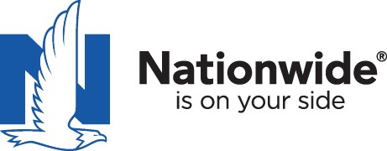
Nationwide Long-term Care Web Series
Business Life Insurance Education Series

2017 Training

Nationwide CareMatters: Approved in CA!
Upcoming Training Webinars

All webinars are 12 – 1 p.m. Pacific Time
Reserve your webinar seat now!

Nationwide is proud to announce that Nationwide YourLife CareMatters® is approved for sale in California.
A fixed premium, linked-benefit product that bundles long-term care coverage and life insurance, this solution allows clients to better address LTC expenses while remaining in control of their assets.
Join Nationwide and Jon Thomas, CareMatters Wholesaler, as he discusses this unique linked-benefit product. This insightful webinar will help you get a deeper understanding of CareMatters, including:
• What is CareMatters and how does it work?
• How CareMatters differs from other LTC products
• Indemnity vs. reimbursement — what you may not know
• A different way to compare product pricing
• How to position CareMatters
• Who is the right client?
• How to discuss solutions with high-net worth client
Copy and paste the following link into your web browser to register for one of our training sessions. After registering, you will receive a confirmation email containing information about joining the webinar.

https://attendee.gotowebinar.com/rt/8706158854246109186

Available Training Dates:
- Oct 12, 2017 12:00 PM PDT
- Oct 19, 2017 12:00 PM PDT
- Nov 02, 2017 12:00 PM PDT
- Nov 09, 2017 12:00 PM PST

Call Nationwide with any questions 1-888-767-7373

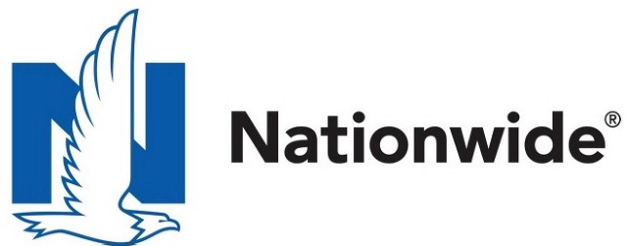
Life insurance products are underwritten by Nationwide Life Insurance Company or Nationwide Life and Annuity Insurance Company, Columbus, Ohio.
Nationwide, the Nationwide N and Eagle and Nationwide is on your side are service marks of Nationwide Mutual Insurance Company. © 2017 Nationwide
FOR INSURANCE PROFESSIONAL USE ONLY — NOT FOR DISTRIBUTION TO THE PUBLIC
FLE-0344CA (09/17)

